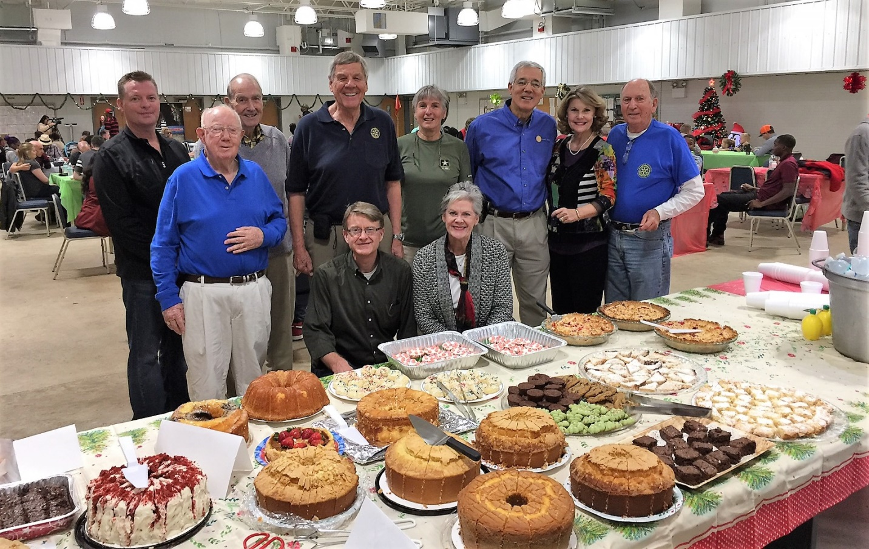

The Rotarians and others who prepared the Holiday meal are shown behind a selection of the homemade desserts provided by the Rotarians. Pictured in the back row are Bob Macdonald, Ed Titus, Joe Brown, Rae Pike, President Jeff Zoller, Sallijo Archer, John Glenn, and in the front row Ed Elam, Grady Enlow and Leisa Zoller

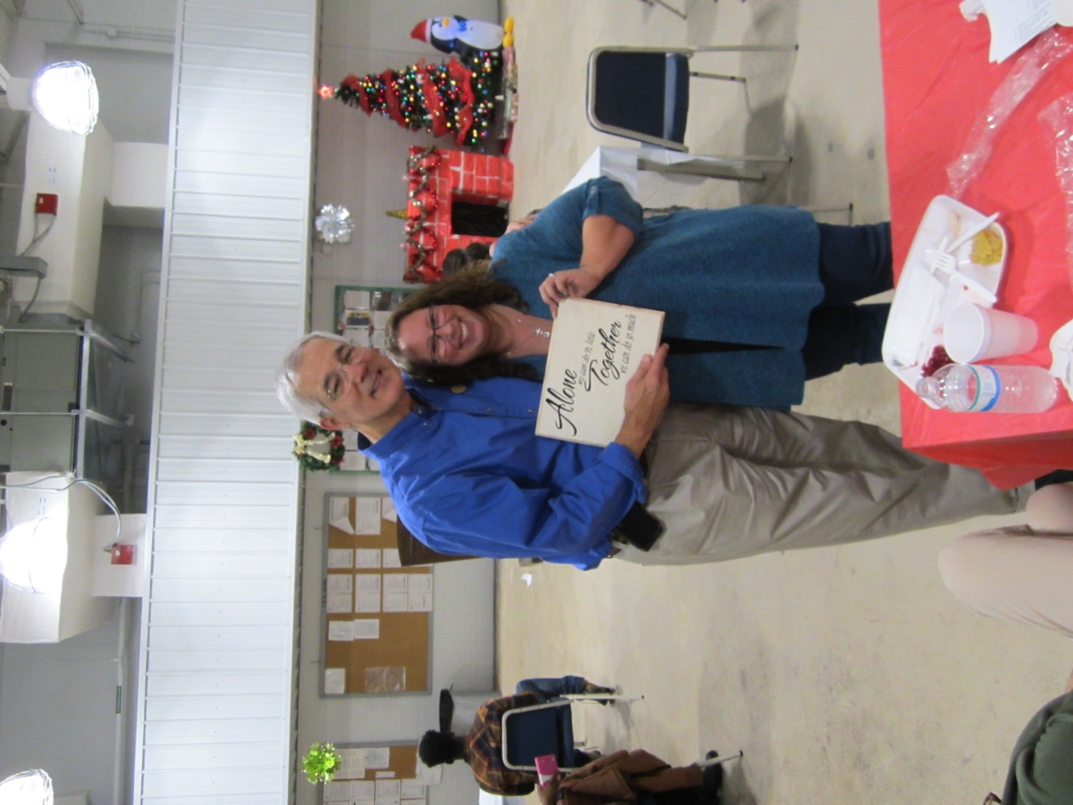

On behalf of the Rotary Club of Thomasville President Jeff Zoller receives a thank you Plaque from Michele Lopez, the Family Resources Group Coordinator the 1230th Transportation Company. The Plaque reads Alone we can do so little, Together we can do so much.

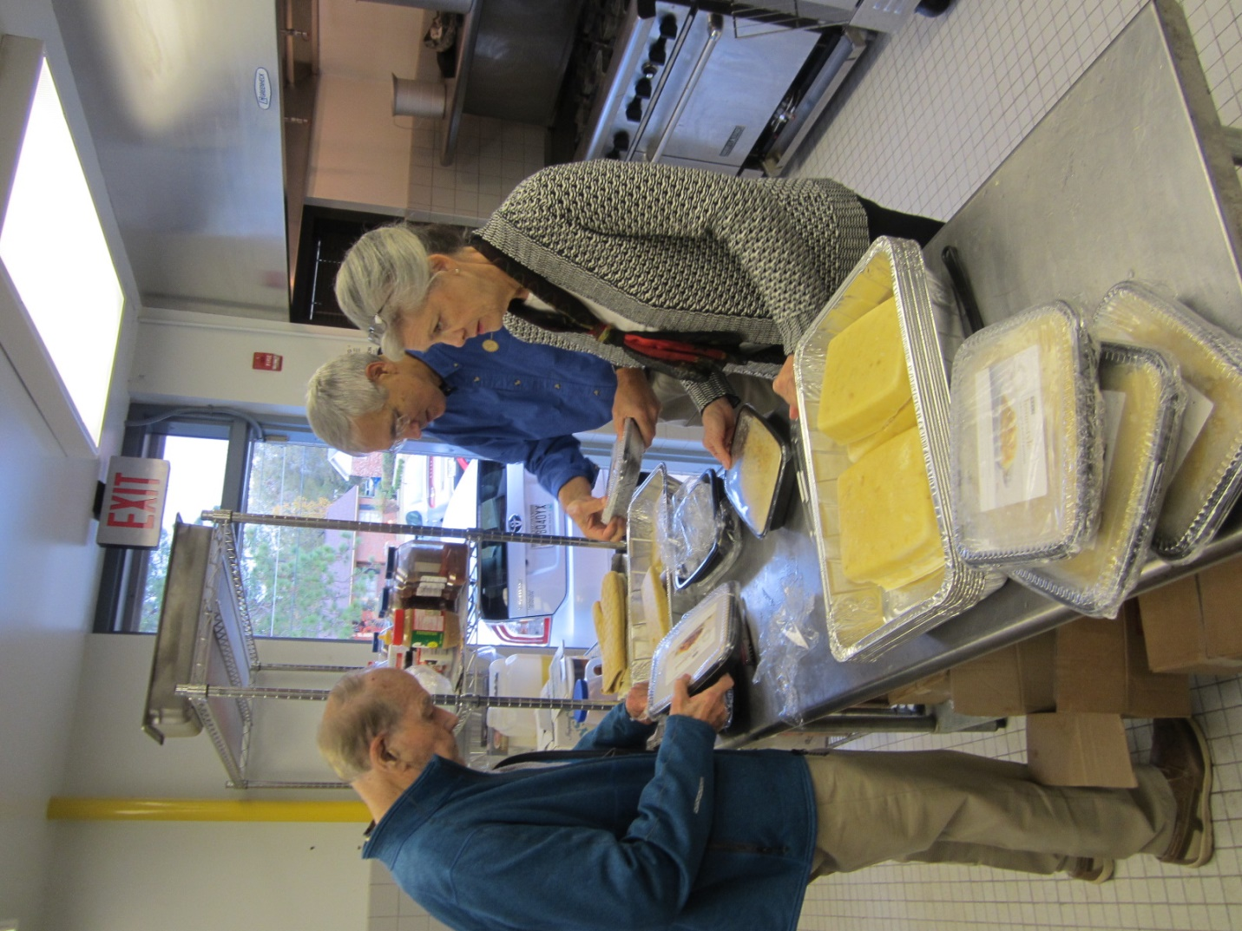

President Jeff Zoller, First Lady Leisa Zoller and Ed Titus prepare the dressing for the Holiday meal.

Sergeant Keanon Tinney

Works with Hands on Thomas County, did cleanup after storms and finger painting at the hospital with kids.

Specialist Michael Donaldson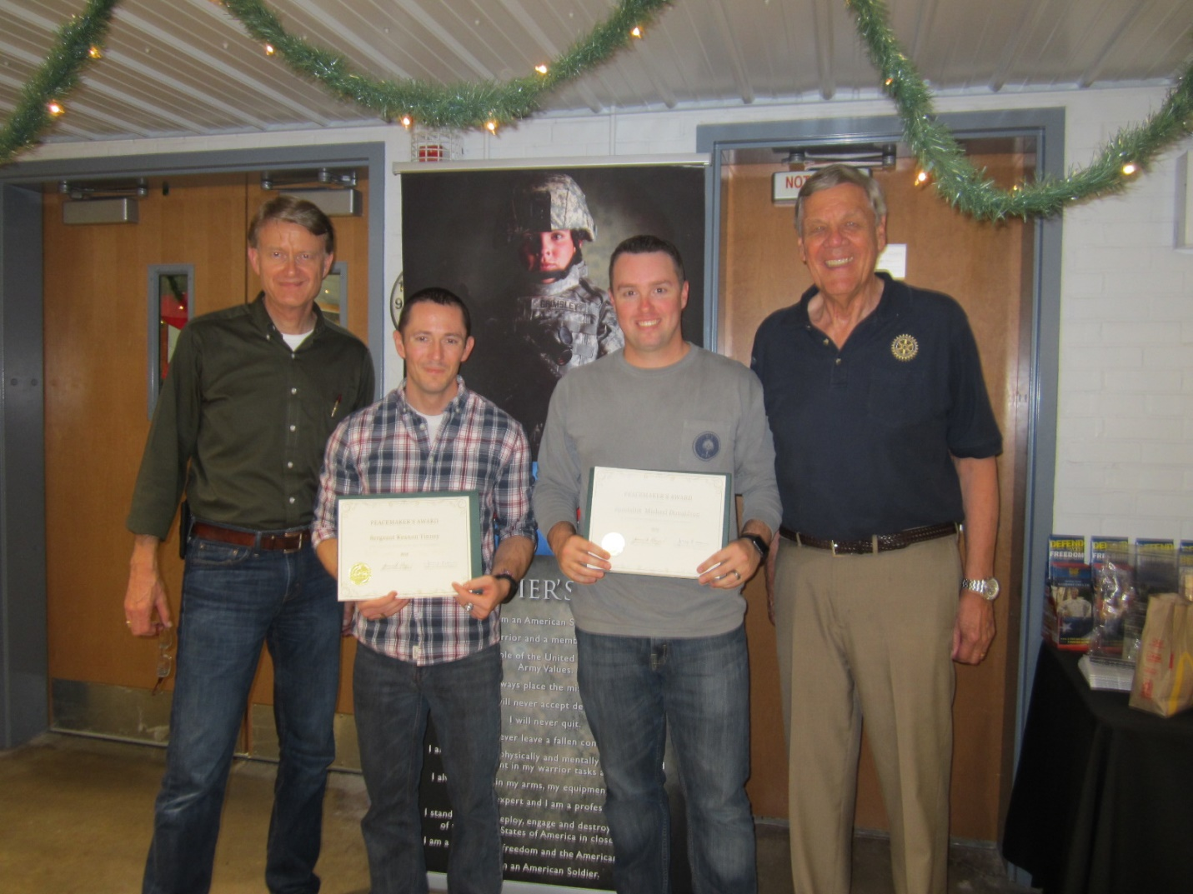

Pictured are Sergeant Keanon Tinney and Specialist Michael Donaldson of the 1230th Transportation Company who received Peacemaker awards for their community service from Thomas University Vice President and Rotarian Grady Enlow on the left and Joe Brown, a member of the selection committee.



The children enjoyed playing in the Bounce House and slide provided by the Club.