GRSP MLK Leadership Weekend service event “Stop Hunger Now”

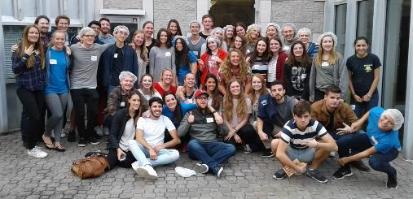

below: GRSP students at the Center for Civil and Human Rights, Atlanta

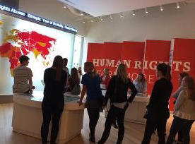

below: GRSP students and weekend host families at a one of the Saturday evening Social

