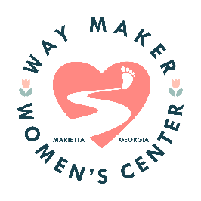 | 3956 Due West Road  Marietta, GA 30064
August 23, 2024
Dear Rotary Members,
We continue to be blessed by you and are so appreciative of your support.
As we continue to grow and support the women in our community and the surrounding communities our needs are growing as well. Your gift of $1000.00 will allow us to further our reach to these women and show them God’s love through your generosity.
We are implementing a mentoring program in 2025. Our goal is to guide them on a larger scale with life skills, goal setting and planning, time management and encouraging self-confidence and independence.
We thank you for your support and confidence in our mission/vision. Please continue to pray for Way Maker and the women who come to this ministry for help.
Many blessings,
Kerri Casteel/Director/Way Maker Women’s Center

