**To:** District 6900 Newsletter Editor

Attn: Jackie Cuthbert

cuthbert@mindspring.com

**From:** Jon Yaeger [jonyaegerrotary@gmail.com](mailto:Jonathan.yaeger@gmail.com)

(404) 610-9386 (cell)

Date: September 24, 2016

**Nicholas House & the RCNA: 20+ Years of Service**

Nicholas House is a shelter that specializes in helping homeless families to achieve self-sufficiency. It started in the halls of St. Bartholomew’s Episcopal Church in 1982; moved to a building behind the church, and then relocated to a much larger facility on Boulevard in metro Atlanta.

The Rotary Club of North Atlanta (RCNA) has enjoyed a strong relationship with Nicholas House that has lasted more than twenty years. Jon Yaeger, an RCNA member, served the program when it started in the church. Rotarian Juliet Reising also served as President of the Nicholas House Board. So far this year, North Atlanta Rotary has provided over $1500 in support of Nicholas House facilities and services.

On Tuesday, September 13th the RCNA participated in a hands on service event when several Rotarians planned, prepared, delivered and served dinner at the shelter house.  More than 19 children from families that are now participating in the Nicholas House Program attended; more than 35 individuals were served.

Dinner participants enjoyed baked and fried chicken, pulled pork with BBQ sauce, green beans, potato salad, rolls, cookies, brownies, fruit pops, lemonade, ice tea and milk!

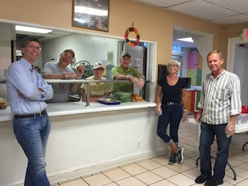

**Figure 1**. RCNA Nicholas House Volunteers

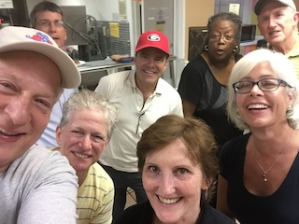

**Figure 2**. Volunteers with friends and family

* * *