In July, we held a bowling night at our local bowling alley. We encouraged members to bring their families by offering “kids bowl free” and advertising that prizes would be given. We had grandkids come, spouses come, and we had a Rotarian bring his girlfriend and parents to bowl. Some Rotarians came just to watch, while others joined in on the fun and bowled a few games. Everyone’s name was put into a hat for a chance to win one of three prizes purchased at one of our local downtown shops.

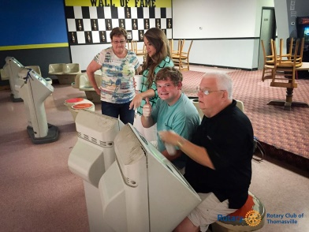 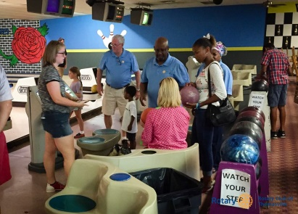

In September, our GRSP Student Reception was held at the Thomasville Center for the Arts, a no cost event space due to Rotarian membership. Our members provided excellent hors d’oeuvres, and a Rotarian gifted his bar service company with only the cost of beverages. Rotarians were able to meet our GRSP college student from Guatemala, a very intelligent young man who shared in delightful conversations throughout the evening. Members brought their spouses and enjoyed the interactions.

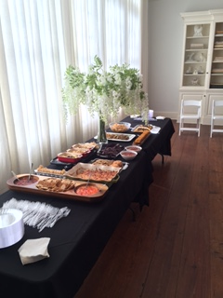 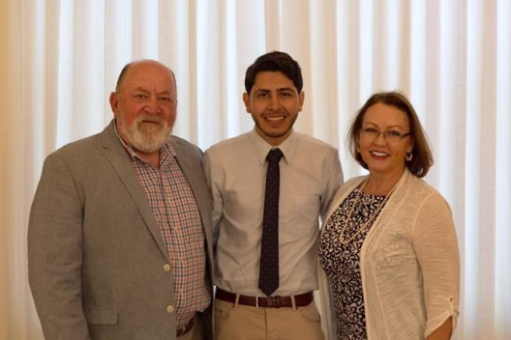

In October, Rotarian Scott Rich opened his home to welcome District Governor Raymond Ray and his wife. This high attendance event brought Rotarians and spouses of all ages. Scott and Peggy graciously prepared food, catered food, and provided beverages at no cost to the club. They were excellent hosts and provided a memorable time to fellowship.

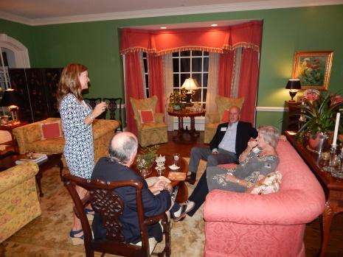 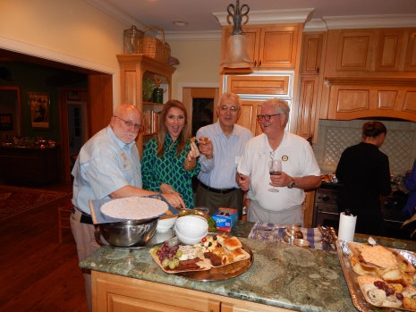

In December, Rotary sponsored a holiday meal for our local National Guard. We wanted all of our club members to have the opportunity to give back, so we asked Rotarians to bake a delicious home cooked dessert. The response was tremendous. Several Rotarians provided more than one dessert, and others stayed to help serve our local heroes. Families present appreciated the holiday smells and tastes.

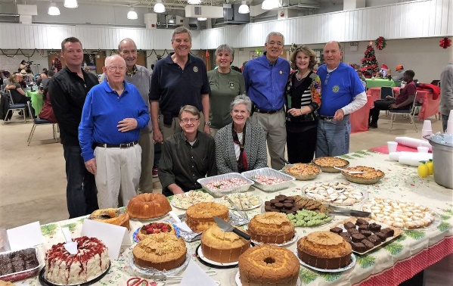

In January, a Pool Tournament was held at our local pool hall. The establishment was closed to the public, so Rotarians were able to let loose. Pool sharks of yesteryear and pool sharks of today were in attendance, as well as those who wanted to join in just for the fun of it. Other Rotarians and spouses came to watch and cheer. A small trophy was awarded to our winner. Our only cost was $100 for the bartender to serve the beverages and renowned chili dogs. This event sparked conversation of continuing an annual pool tournament and perhaps challenging the Kiwanis Club to peak more interest.

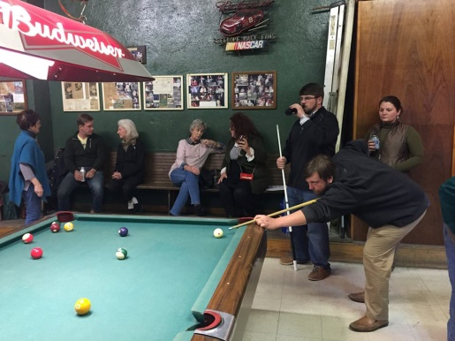 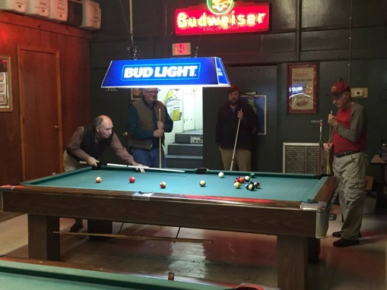

We project Grand Evening to be another wonderful evening held at Glen Arven Golf Club. Last year we had 116 in attendance. A spouse of a Rotarian gives of her talents by arranging the centerpieces. The atmosphere is so inviting and allows Rotarians and spouses to mingle before the meal. As the premier Family of Rotary event, a special pianist delights us with soothing sounds, special guests join us (District Governor, spouses of past Rotarians, etc), and awards of all the yearly achievements are presented.